TERMWORK 3
NAME: name_here
USN: 2GI20CSXXX

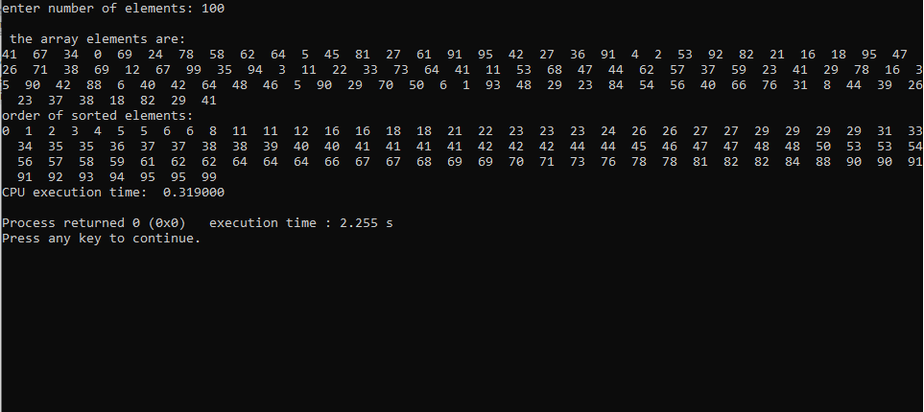

n | t
100 | 0.315
200 | 0.951
300 | 1.691
400 | 2.79
500 | 3.918
600 | 5.273

